Technology class

Gears

Member:
Martín Alejandro Guarda Cortés
Grade: 9th grade (1° Medio) “A”
Date: 16/05/2012
Teacher:
Jorge Arturo Leighton Garces

INDEX
-Introduction
-Gear Classification
-Cylindrical Gears
-Conical Gears
-Endless Screws
-Conclusion

Introduction

This essay will give basic information about gears; most information was collected from various web pages and was redacted in an easy-to-understand way.
Since ancient times, gears have been used as transmission systems, but their shape and the materials used in their construction have changed since then.
The creator of gears was Leonardo da Vinci, who left us valuable drawings and schemes about these mechanisms that we use daily.
All the types of gears are resumed into three categories:
-Cylindrical gears
-Conical gears
-Endless screws

Gear Classification

Cylindrical Gears

They are created by cutting a cylindrical disc. This disc is taken to the piercing process where the “teeth” are formed. Making these types of gears is simple, so the production costs are reduced.
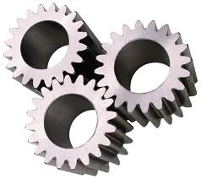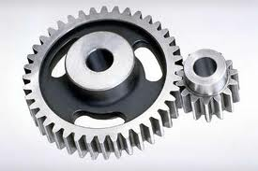

Conical Gears

They are created from a piece of a cone, forming the “teeth” by milling the external surface. The “teeth” are can be straight, helical or curved. Conical gears have their “teeth” cut on the surface of the cone trunk.
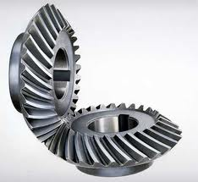

Endless Screw

Usually cylindrical, they can be considered helical derivatives, the screw being a helical wheel of one “teeth” or more.
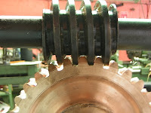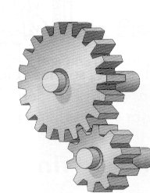

Conclusion

Gears are the easiest way to transmit movement. Their construction isn’t simple but it’s easy to understand, we use them daily and their utility depends on where they’re used, because of that, gears are a great progress in mechanics in general.

